Third Grade Supply list
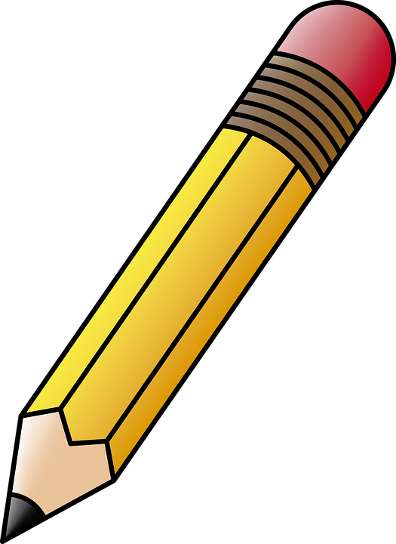
Please send the following supplies to school with your child on the first day.

2 or more boxes | Ticonderoga pencils (at least 50 pencils)
3 | Pink Pearl erasers
4 | Large Elmer’s brand glue stick (.77 oz.)
1 | Pair of scissors (Fiskars work well)
2 boxes | 24 count Crayola crayons
1 | 12 count Crayola markers
2 | highlighters
3 boxes | tissues
headphones | Bluetooth does not always work on a chromebook
2 | Dry erase markers

- Water bottles must be no larger than 24 oz. and have a lid that closes securely to prevent spills
- No backpacks with wheels
- No pencil sharpeners please

